Why Restful
Restful mostly came into popularity due to the following reasons:
- Heterogeneous languages and environments – This is one of the fundamental reasons which is the same as we have seen for SOAP as well.
- It enables web applications that are built on various programming languages to communicate with each other
- With the help of Restful services, these web applications can reside on different environments, some could be on Windows, and others could be on Linux.
But in the end, no matter what the environment is, the end result should always be the same that they should be able to talk to each other. Restful web services offer this flexibility to applications built on various programming languages and platforms to talk to each other.
The below picture gives an example of a web application which has a requirement to talk to other applications such Facebook, Twitter, and Google.
Now if a client application had to work with sites such as Facebook, Twitter, etc. they would probably have to know what is the language Facebook, Google and Twitter are built on, and also on what platform they are built on.
Based on this, we can write the interfacing code for our web application, but this could prove to be a nightmare.
Facebook, Twitter, and Google expose their functionality in the form of Restful web services. This allows any client application to call these web services via REST.
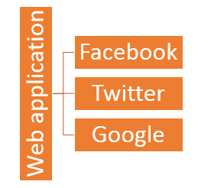
- The event of Devices – Nowadays, everything needs to work on Mobile devices, whether it be the mobile device, the notebooks, or even car systems.
Can you imagine the amount of effort to try and code applications on these devices to talk with normal web applications? Again Restful API's can make this job simpler because as mentioned in point no 1, you really don't need to know what is the underlying layer for the device.
- Finally, is the event of the Cloud – Everything is moving to the cloud. Applications are slowly moving to cloud-based systems such as in Azure or Amazon. Azure and Amazon provide a lot of API's based on the Restful architecture. Hence, applications now need to be developed in such a way that they are made compatible with the Cloud. So since all Cloud-based architectures work on the REST principle, it makes more sense for web services to be programmed on the REST based architecture to make the best use of Cloud-based services.

